A000-EUR-Sweden-Gotland-Visby-Viking-Box Brooch-Silver and Cloisonné-1100 CE

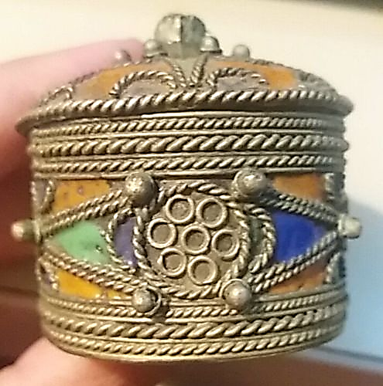 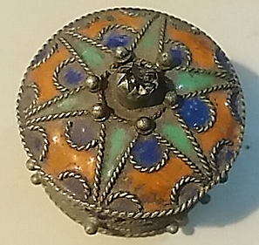 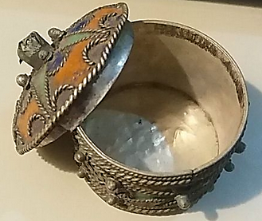

Figs. 1-3. Sweden-Gotland-Visby-Viking-Box Brooch-Silver and Cloisonné-1100 CE

**Case no.: 4**

**Accession Number:**

**Formal Label:** Sweden-Gotland-Visby-Viking-Box Brooch-Silver and Cloisonné-1100 CE

**Display Description:**

This important Box Brooch of gold and silver-plated bronze would have been used by a woman from Visby, Gotland, off the coast of Sweden. Made in a style seen nowhere else in Scandinavia, it would have been a sure sign to all of her ethnic identity, and her high social status marking this as the apogee of Viking wealth about 1100 CE. The style of this Box Brooch has twisted braiding that encompasses with a six-pointed star motif areas of cloisonné in orange, green and blue. Silver orbs have been applied at important conjunctions in the angular design motifs and single silver circles have been added within braided silver circles on the sides perhaps signifying that the owner was related to Viking royalty and that these were the symbols of the Visby dynastic crown connecting it with the six-pointed star that encompasses the design on the lid and suggests the encompassing centrality of Visby in the Viking world of Norway Denmark, Finland, Estonia, Latvia and Lithuania.

**LC Classification:** DL991.V5

**Date or Time Horizon:** 1100 CE

**Geographical Area:** Visby, Gotland

**Map:**

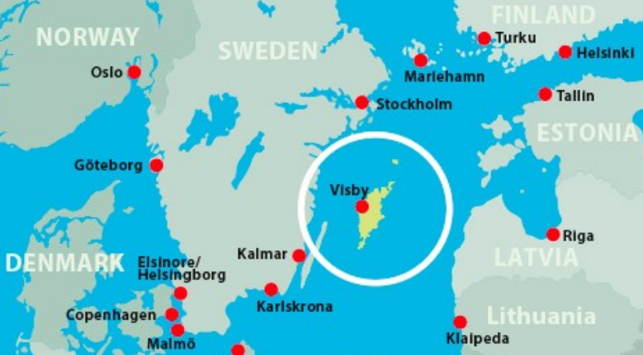

**Location of Gotland after http://www.europeancivilwar.com/wp-content/uploads/2016/10/Gotland-1.jpg**

**GPS coordinates:**

**Cultural Affiliation:** Swedish Viking

**Media:** gold and silver-plated bronze

**Dimensions:**

**Weight:**

**Condition:**

**Provenance:**

**Discussion:**

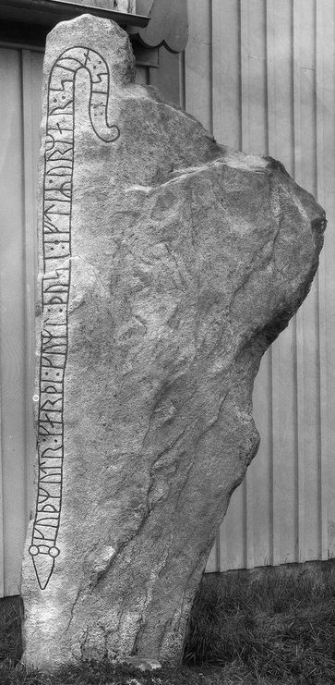 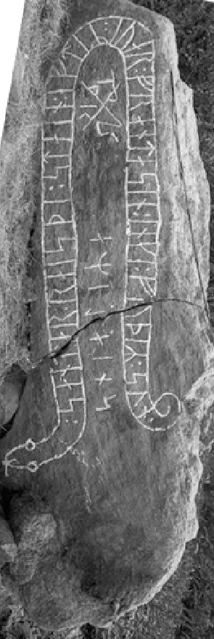 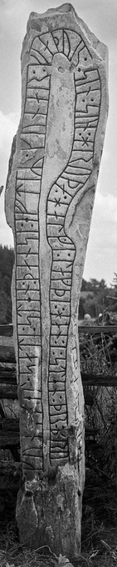

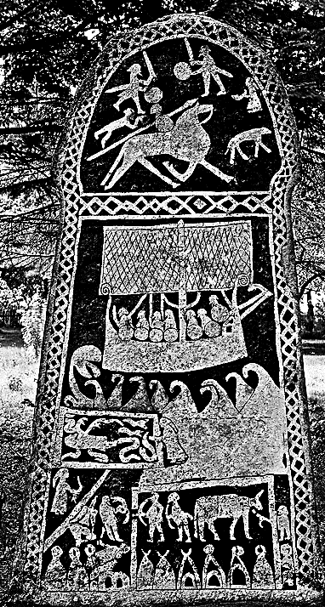

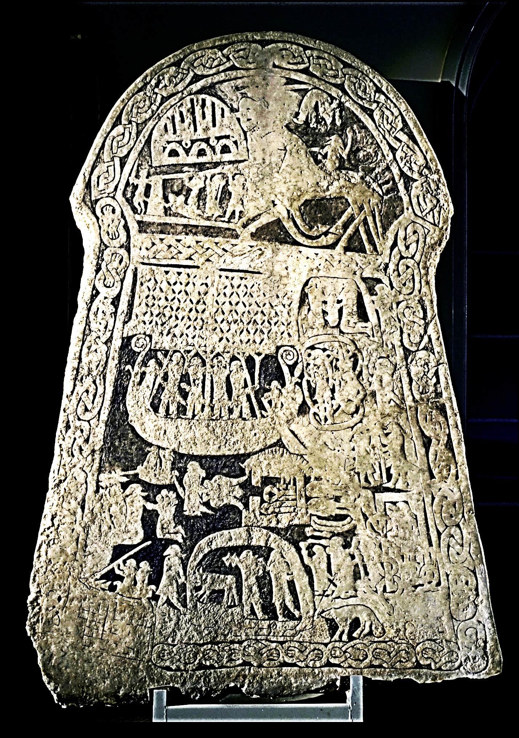

Ancient picture stone showing figures from [Norse mythology](https://en.wikipedia.org/wiki/Norse_mythology). From Ardre Parish, Gotland, Sweden. Now at the National Historical Museum in Stockholm, Sweden,

The Viking Age was a time of transition as Viking raiders returned to their homes with foreign slaves, new materials, and revolutionary ideas. Viking chieftains often assented to accepting Christianity as a condition of peace agreements but their conversion was another matter as the old gods and goddesses survived. Small farm production increased in productivity and as a result expendable wealth allowed the development of organized craft centers in places like York and Birka. As royal wealth increased, local areas gradually lost sovereignty to national kings. By the early 12th century, Scandinavian had become integrated into medieval, Christian European society, and descendants of Vikings who had settled abroad had little in common with their pagan ancestors.

**References:**

Blomkvist, Nils. 2007. *The significant detail: Europeanization at the base of society : the case of the Baltic rim 1100-1400 AD ; transactions of the CCC workshops at Skäftekärr in Sweden 7-10 October 1999, and at Tukums in Latvia 15-18 April 2000*. Visby: Gotland University.

Wåhlin, Hans Frederik Theodor. 1938. *Visby and the ancient civilisation of Gothland*. Stockholm: P.A. Norstedt.